Nerve Solution Assignment:

Creating Console Application for both client and server (Proof of concept) :   
  
Server code :   
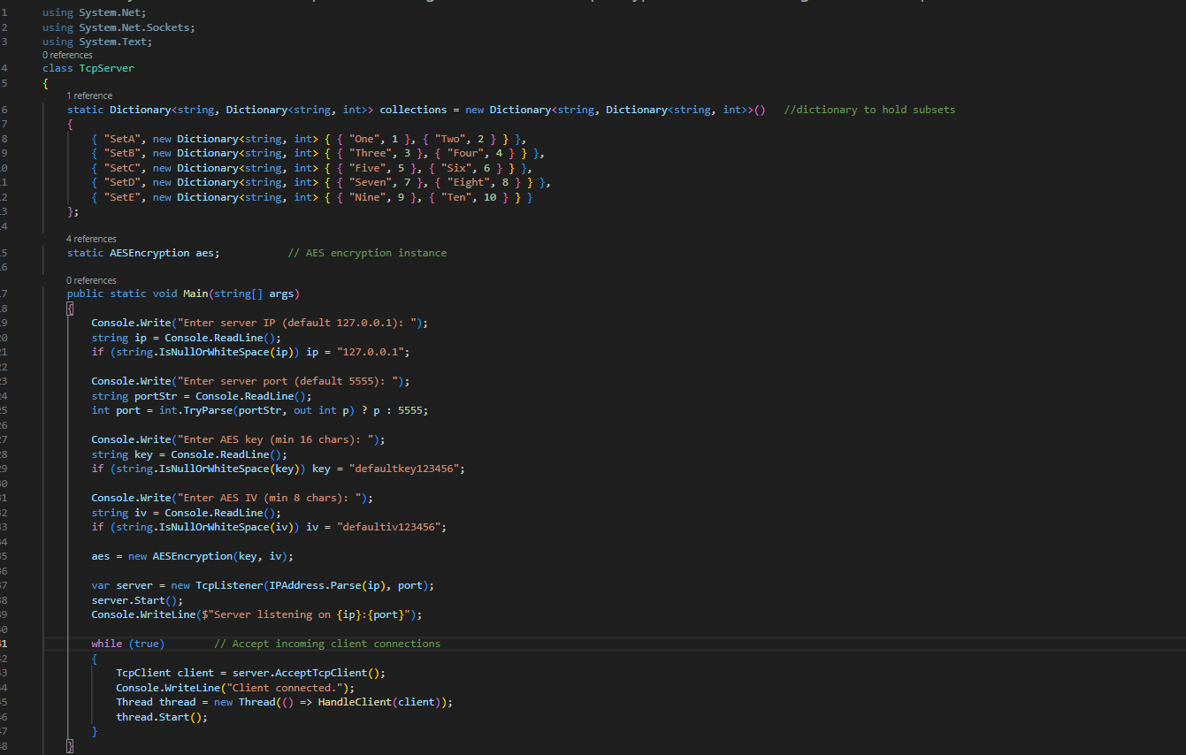

For handling client : above while loop for handling client by using threads for every client.  
